**DealersCloud App**

(Current Status)

# ✅ Completed Modules

* **Dashboard**: CRM & Inventory stats, Inventory Age Chart, revenue chart, lead status breakdown
* **Inventory**: Add/update vehicle, VIN scanner, vehicle listing, image/doc upload etc…
* **CRM**: Add lead, co-buyer then sub Tabs against each lead such as Timeline, Tasks, SMS, Notes, Appointment,, Documents etc…. (few in process)
* **Chat**: Internal chat (text only)
* **User**: Profile, password, preferences, login etc…
* **Credit App & Trade-in**: All screens completed with field validations
* **Your team member asked work done:** Please remove the 'Type' dropdown from the screen below, as it is not related to vehicle purchases

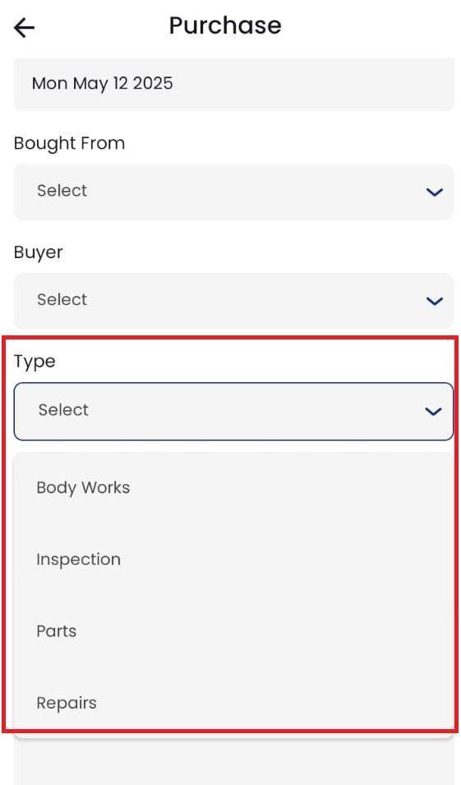

# 

* **Feature Added**  with API Integration of Remove, Return / Arbitrate actions in Inventory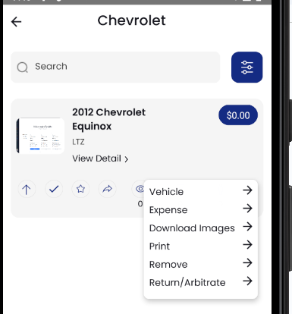
* Type field (New/Used) design added and integration with API also done

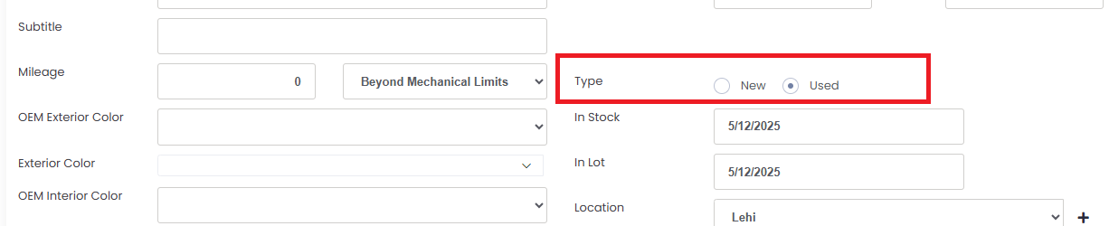

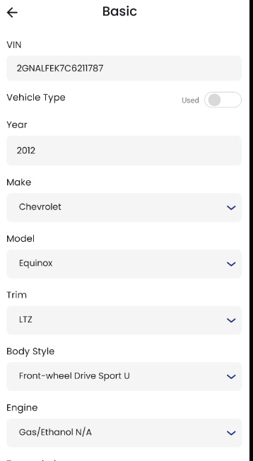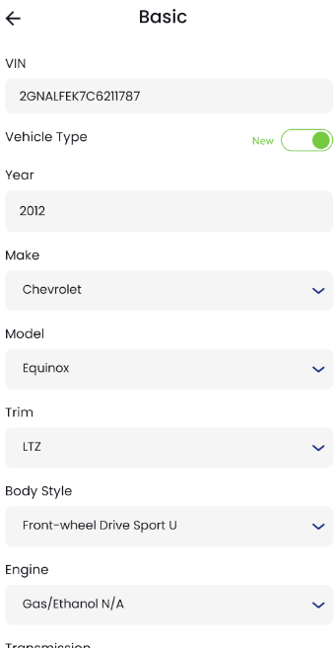

* Add Payment option to Vehicle Purchase – Design & backend both completed including floor plan and consignment option with Tow Tabs Feature: Purchase Info & Payment.

Design, API and integration Status done

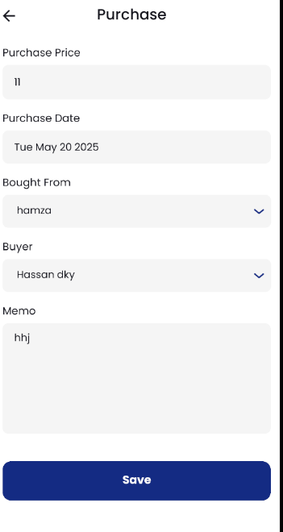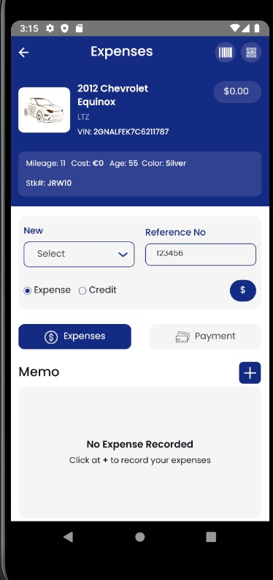

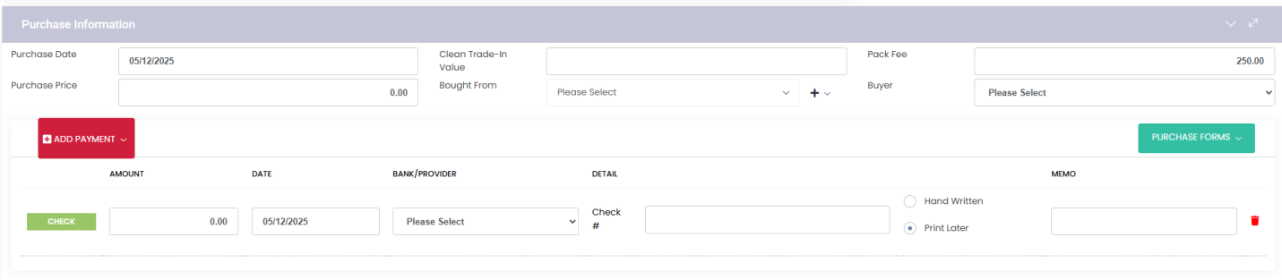

* Your Team Member said that Please include Stock No., VIN, Mileage, Age, Live Status, and Drive Type on the screen below.  
  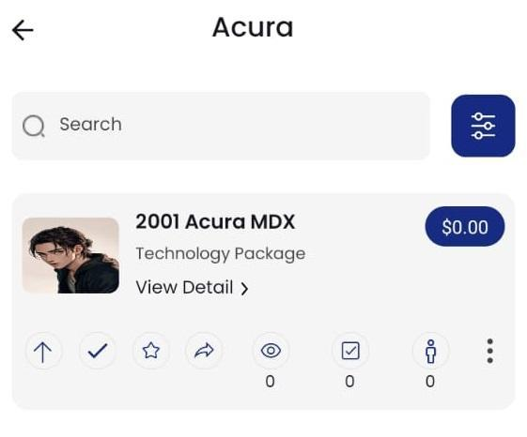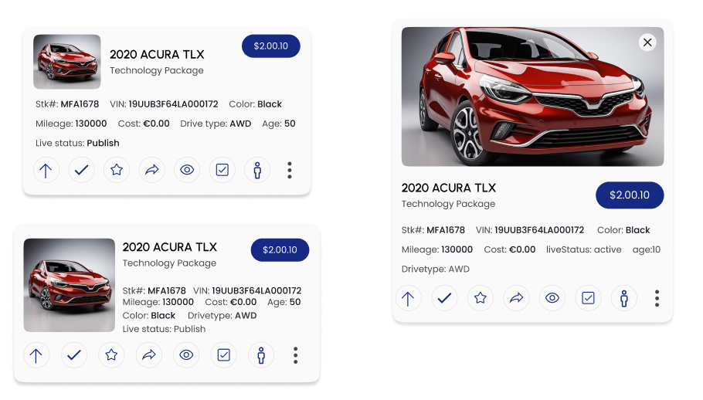



# 🟡 In Process…

(Design and API Development Completed but API Integration in Process)

* **CRM tabs ( Add buttons to add Task, Notes, Appointments, SMS, Email, and Deal)**

**Completed (Design/API/Integration):** Timeline, Tasks, Notes, Appointment, SMS,Profile, Document,

***InProcess:*** VEHICLE, EMAIL, App Design Completed Integration In Process

* Watermark Feature API Completed and Design and integration pending

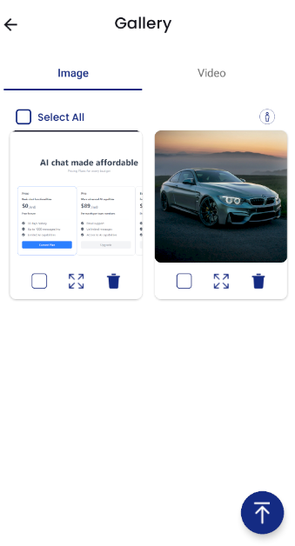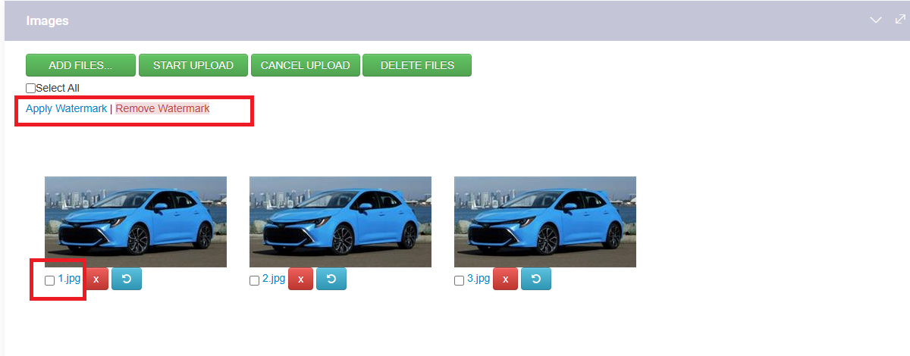

* Add YouTube and 360 Video buttons to the Images tab.

**APIs Created to handle video Links** but Video Tab Integration is Pending

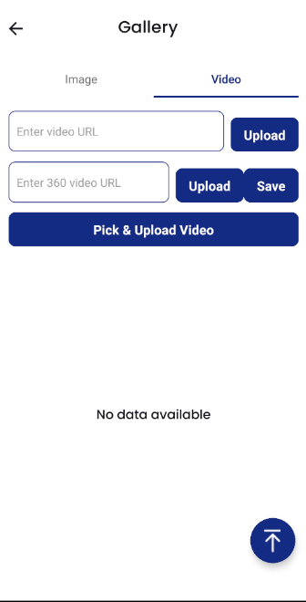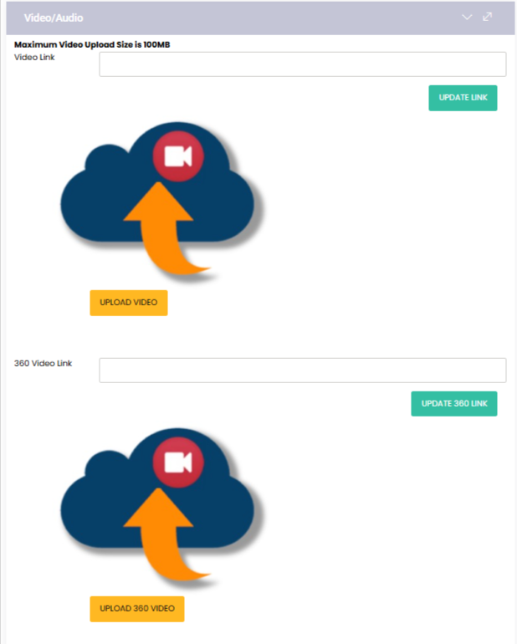

# 

* Vehicle Actions panel (Auto Check, Carfax, Push, etc.) – unclear functionality; needs business logic and functionality discussion required **Let’s arrange a meeting.**

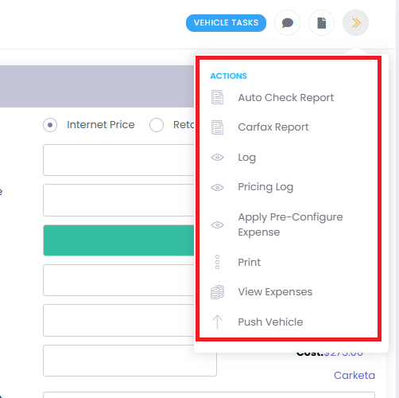

# 📝Pending

* CRM top button shortcuts: what should each one trigger? Such as,

CRM buttons (Reminder, Note, Call, Deal, 4Square, Delete, My Leads) – Require design, API, and full workflow discussion as it require screen design API Development and Integration

also need to discuss

* DEALS
* **MYTASK Tab: Need** to Discuss ? (Not mentioned Anywhere neither in Figma nor by your side)

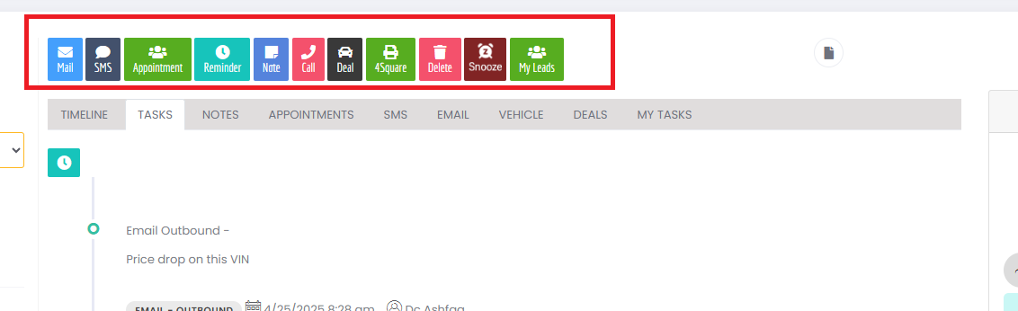

**Questions from Developer**

* Inventory age
  + The task is complete; however, I need to verify one point. In your dashboard query for Inventory Age, there is an INNER JOIN with the VehiclePurchaseView. Ashfaq from the team mentioned that no data is being inserted into the VehiclePurchaseView table, as it is a cache table.  
    Then why there is join with the VehiclePurchaseView ?
* Base Price of Vehicle should which one? as it’s coming from VIN Scanner. there are 3 options  
  **According to Nafees:** Price should be user-defined.